**Slime**

The work was first inspired by looking at a living slime moving very slowly in video games, such as Pokemon’s Ditto. To represent the movement of it, I used glissandos in a small range. Later in the music, I decided to explore a dry and crispy sound to contrast with the slimy section. The texture of the work is an exploration of a fabric built from nuanced, small variations, but interrupted by fragments of noise materials alongside the texture. This also reminds me of Ligeti’s *Lontano*, which introduced a new kind of polyphonic texture called micropolyphony. The structure of the work is fugue-like and it governs the entire of the material, as discussed below. Also, the motif is stated in a variety of ways, such as single line and stretto. The work begins with a single line in the alto flute and progressively introduces new pitches and adds new colours. Furthermore, episodes are mostly timbre based, for example bars 24 – 28. In addition, a contrast of timbre begins in the transition after the climax of the slimy section (bar 53) where a new section with a drier texture is introduced in bar 58.

The pitch material of the work is based on a motif, A♭, G, A, B♭, A, A♭, G♭, G. The motif is confined within a small range for exploring more microtonal material by slow glissandos. However, the main focus in the work is using different timbres to explore the motif. For example, different levels of air pressure on wind instruments and string instruments are played in different areas, such as *sul ponticello*, *molto sul ponticello* or ordinary. Besides that, pizzicato and pitched key clicks on wind instruments are also applied to introduce the motif. The motif is transposed at many registers in the work but once the motif is introduced, it stays in the same octave from the start to the end. Additionally, all changes on timbre and pitch are slow.

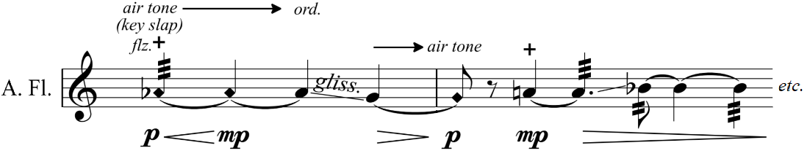

Figure 1: Alto Flute plays different air pressures and key slaps/key clicks in bars 19-20

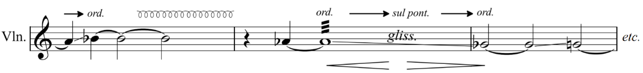

*Figure 2: Violin plays in different areas in bars 9-11*

Regarding texture, I have sought to explore matching sounds between the instruments of the ensemble. I will show examples of a dry texture and an airy and pitch-based texture. In bars 17 – 19, alto flute and bass clarinet play key clicks and violin plays left hand snaps to imitate each other’s sounds. These sounds created a dry and crackling sounding to the work. This idea becomes more developed in bar 24 and bars 29 – 31, but string instruments switch to *col legno* on all strings behind the bridge.

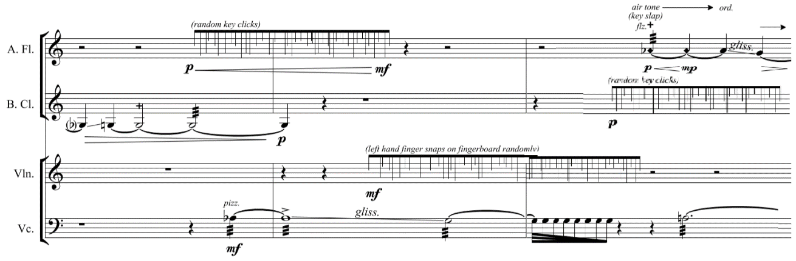  
*Figure 3: sounds matching between alto flute, bass clarinet and violin in bars 17-19*

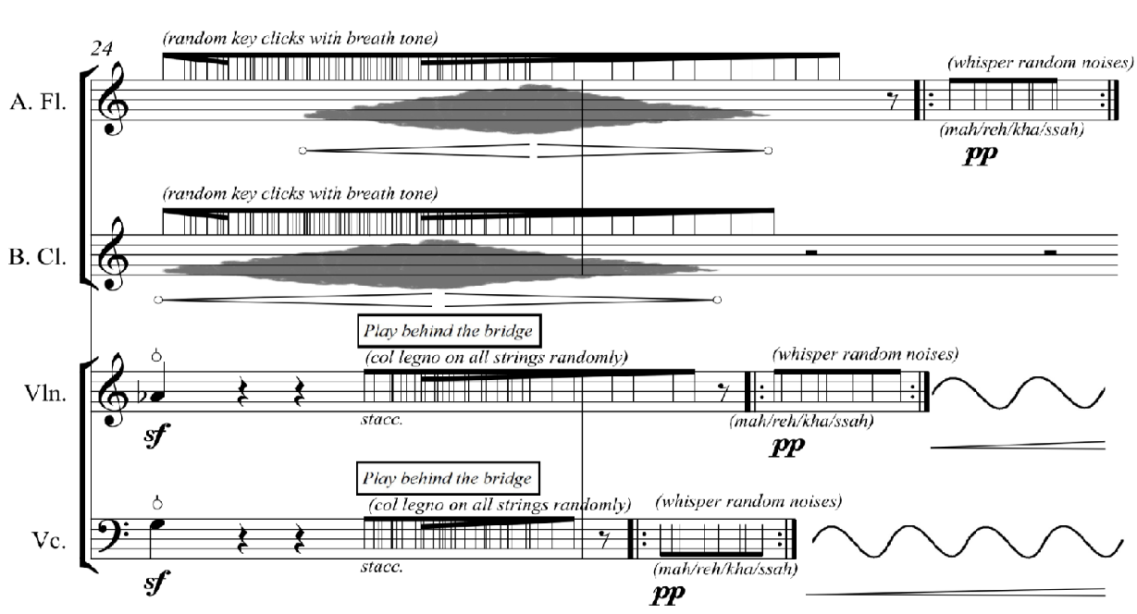

*Figure 4: developed ideas in bars 17-19*

Apart from that, the sound matching between the instruments is demonstrated in bar 32 and 38, which creates the airy sounding. It is preceded by a single line motif in alto flute accompanied by bass clarinet, violin and cello playing key clicks and *col legno* on all strings behind the bridge.

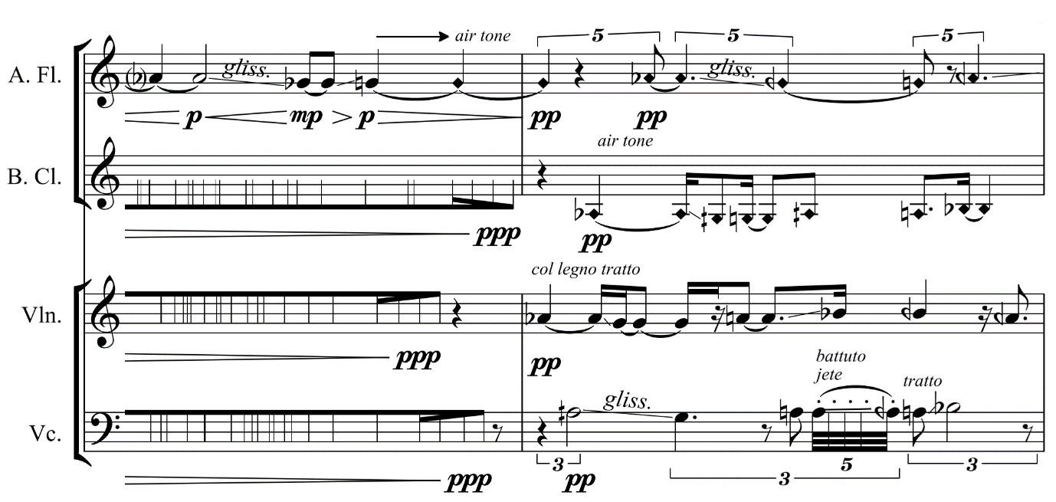

*Figure 5: sounds matching with all instruments in bars 31-32*

Additionally, I experimented with an extended technique on cello, tremolo with repeating pizzicato. This is a technique coming from plucked string instruments, such as guitar and mandolin. Then, the technique is transferred into the cello, which creates a different timbre. Also, this sound is used to match the sound of flutter tonguing by wind instruments.

*Figure 6: cello plays tremolo with repeating pizzicato in bars 17-20*